Jackson Gross

Circle HW

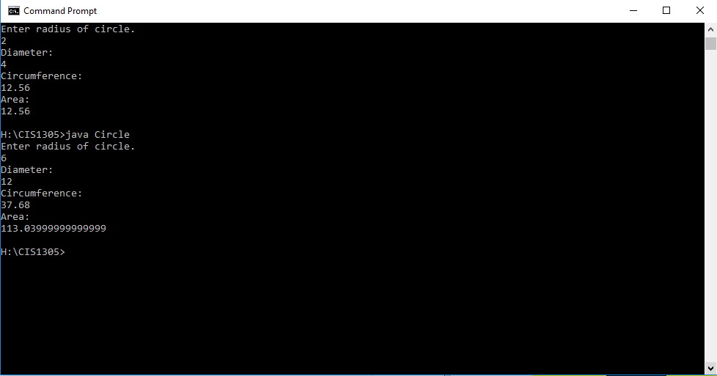

import java.util.Scanner;

public class Circle {

public static void main(String args[]) {

Scanner scnr = new Scanner(System.in);

int radius;

int diameter;

double circumference;

double area;

System.out.println("Enter radius of circle.");

radius = scnr.nextInt();

System.out.println("Diameter:");

diameter = radius \* 2;

System.out.println(diameter);

System.out.println("Circumference:");

circumference = 2 \* 3.14 \* radius;

System.out.println (circumference);

System.out.println("Area:");

area = 3.14 \* radius \* radius;

System.out.println (area);

}

}